**[System Flow Diagram for Online Shopping System](https://meeraacademy.com/system-flow-diagram-for-online-shopping-system/)**

System flow chart for online shopping website

The system flow diagram is a visual representation of all processed in sequential order.  
The System flow chart diagram is a graphical representation of the relation between all the major parts or step of the system. Flow chart diagram can not include minor parts of the system.

Flow Chart diagram symbols​

|  |  |
| --- | --- |
| Symbol | Description |
| [meeraacademy](https://www.youtube.com/coderbaba) | **Start / End :** Represents the start or end point of a flowchart. |
| [dfd symbol](https://www.youtube.com/coderbaba) | **Data Flow :** Data flow are pipelines through the packets of information flow. |
| [dfd process](https://www.youtube.com/coderbaba) | **Process :** A Process or task performed by the system. |
| [meeraacademy.com](https://www.youtube.com/coderbaba) | **Decision :** Decision decides the next step will be proceed or not. Yes/No, True/False |
| [meeraacademy](https://www.youtube.com/coderbaba) | **Input / Output :** Represents input and output data. |

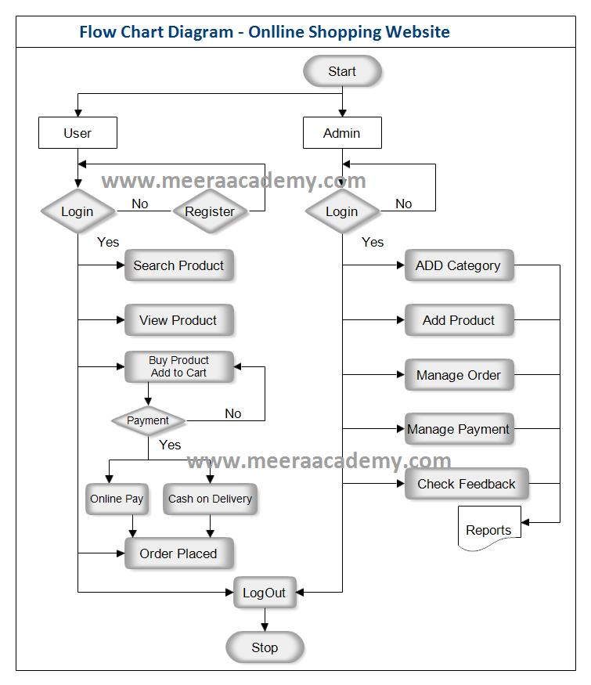Flow Char Diagram for Online Shopping Site